**IntelliFab file**

The mask file has to be imported from the blue print module by browsing the mask file through Die Setup --> Choose --> mask file location

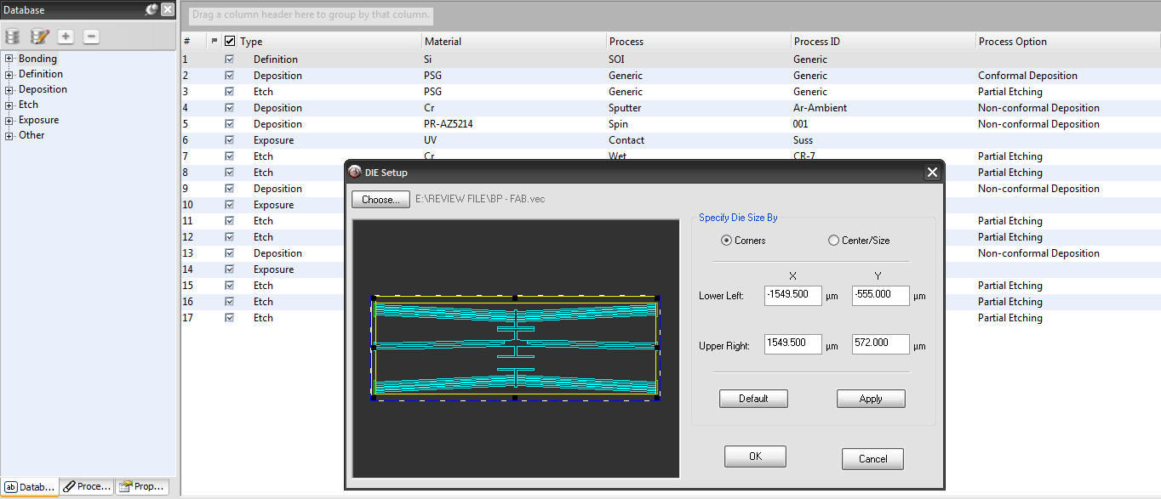

Step 1: Definition of the substrate

Database --> Definition --> Si --> SOI --> Generic

Thickness of substrate - 400000nm

Thickness of oxide - 1000nm

Thickness of device layer Si - 10000nm

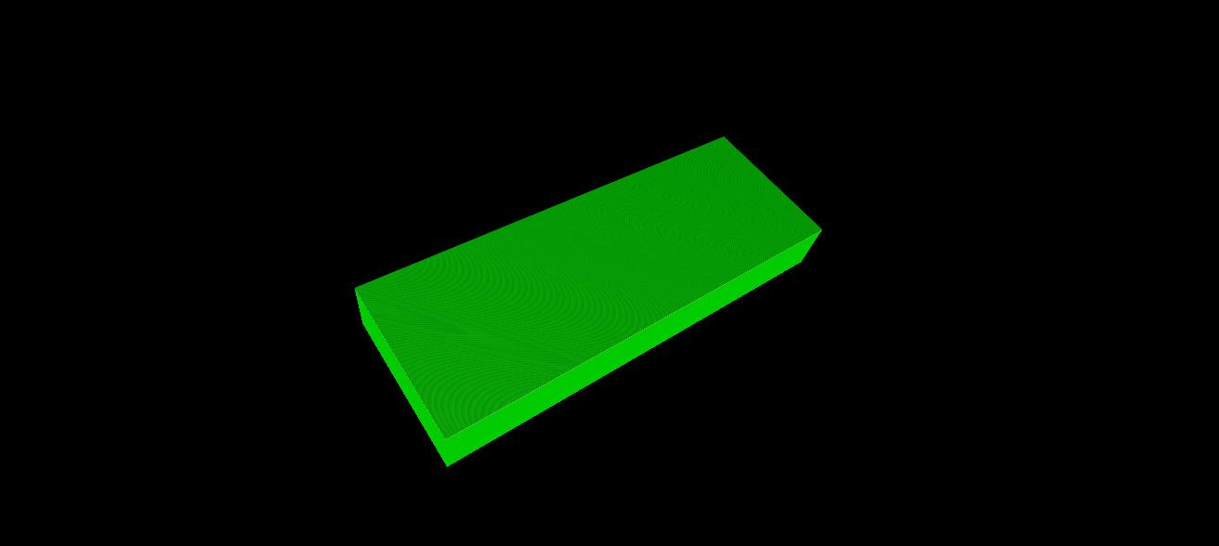

Step 2: Deposition of Chromium metal (contact pad)

Database --> Deposition --> Cr --> Sputter --> Ar-Ambient (Non-Conformal Deposition)

Thickness of Chromium - 200nm

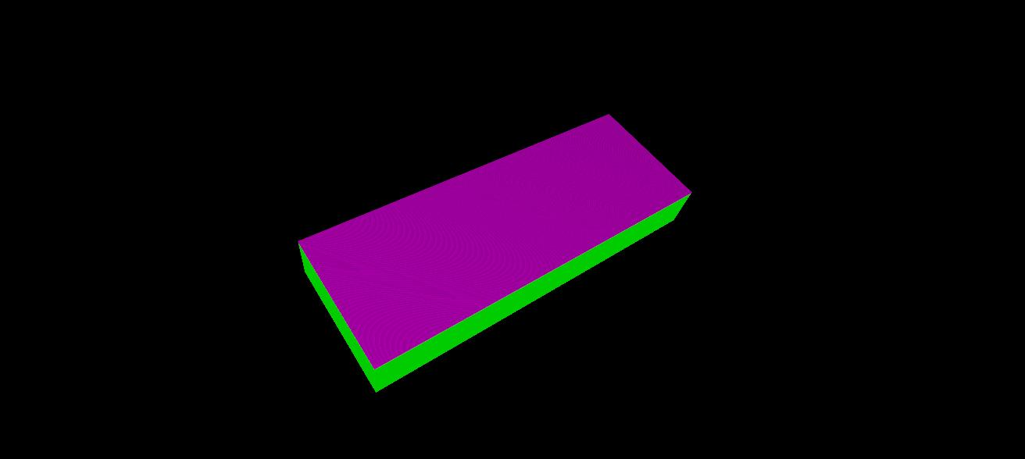

Step 3: Deposition of Photoresist (PR is for the purpose of exposing the mask on top of the chromium to setup the contact pad)

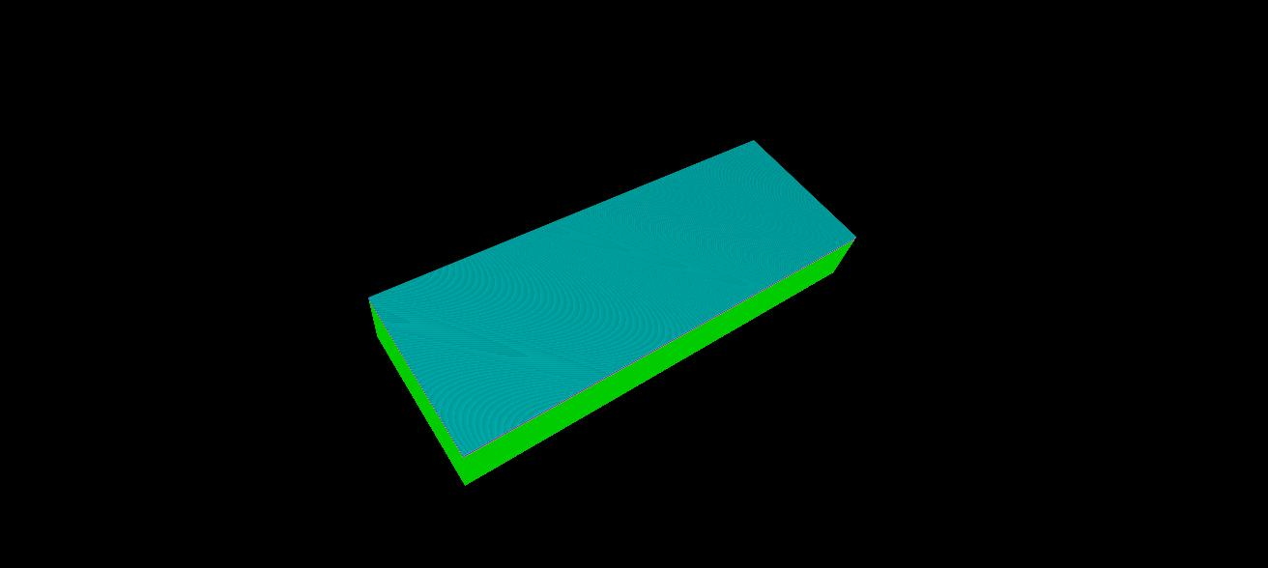

Database --> Deposition --> PR-AZ5214 --> Spin --> 001 (Non-Conformal Deposition)

Step 4: Exposure of UV rays on the top of the PR ( The mask structure of contact pads which has been drawn in layer 1 in the blueprint module has to be uploaded in the fab file)

Database --> Exposure --> UV --> Contact --> Suss

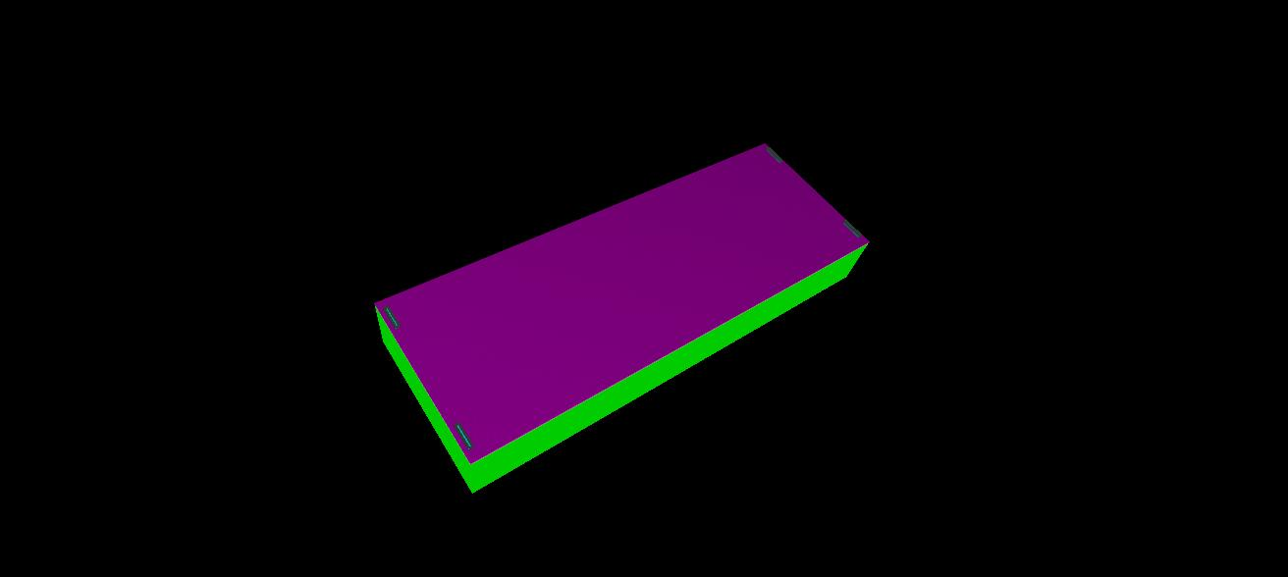

Step 5: Etching of Chromium (Chromium should be etched except at the place where contact pads need to to be present)

Database --> Etch --> Cr --> Wet --> CR-7 --> Partial Etching

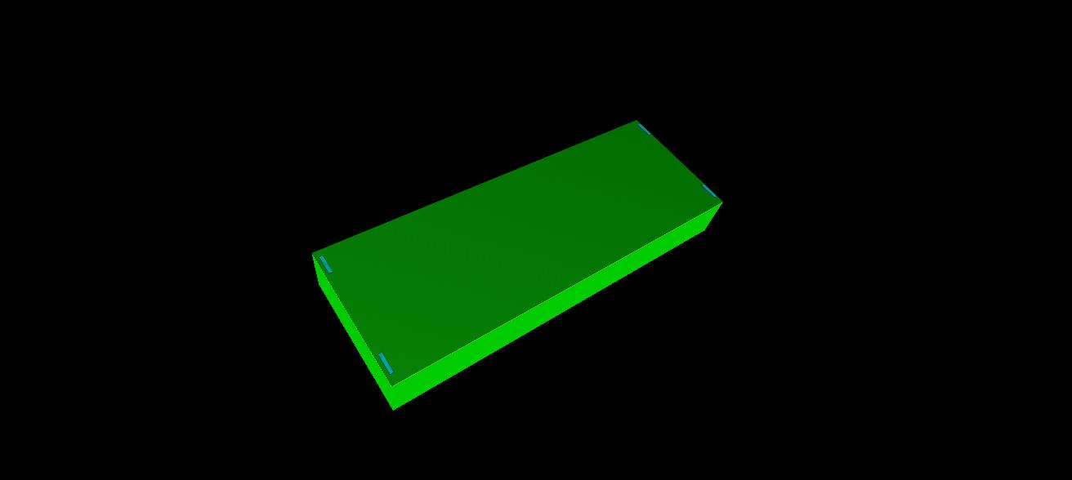

Step 6: Etching of Photoresist

Database --> Etch --> PR-AZ5214 --> Wet --> Lift-off --> Partial etching

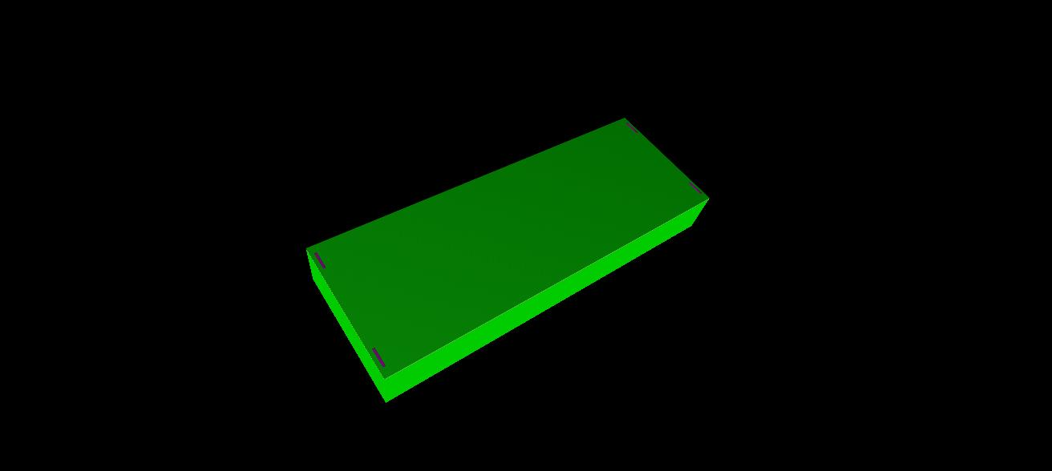

**Note : Chromium should be etched and then photoresist should be etched.**

Photoresist is present only below the mask structure. PR at the remaining area will be removed at the instance of UV rays exposure.

Therefore, the photoresist will protect the Chromium at the place of the contact pad mask and therefore Chromium in the remaining area will be etched.

If the order of etching is reversed, then the contact pad metal will be directly exposed to the UV rays and therefore it will be etched completely without leaving the metal for contact pad.

Step 7: Deposition of Photoresist (For the purpose of the second mask (device) to be uploaded)

Database --> Deposition --> PR-AZ5214 --> Spin --> 001 (Non-Conformal Deposition)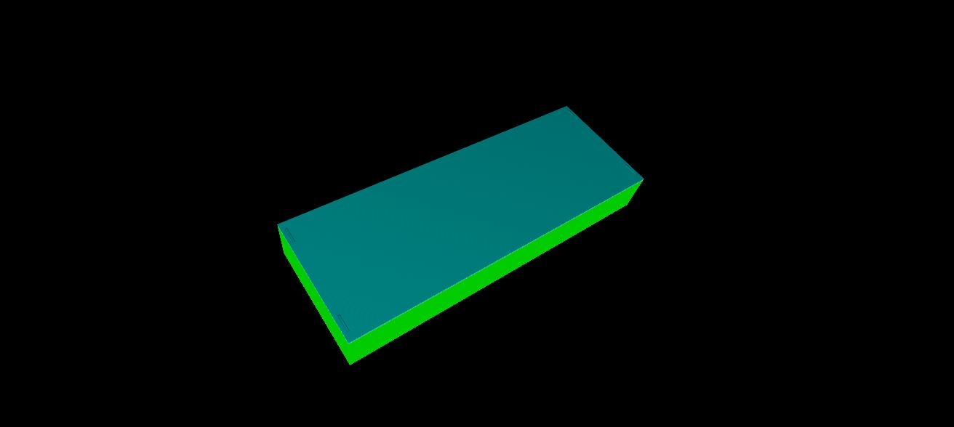

Step 8: Exposure of UV rays on the top of the PR ( The mask structure of the device which has been drawn in layer 0 in the blueprint module has to be uploaded in the fab file)

Database --> Exposure --> UV --> Contact --> Suss

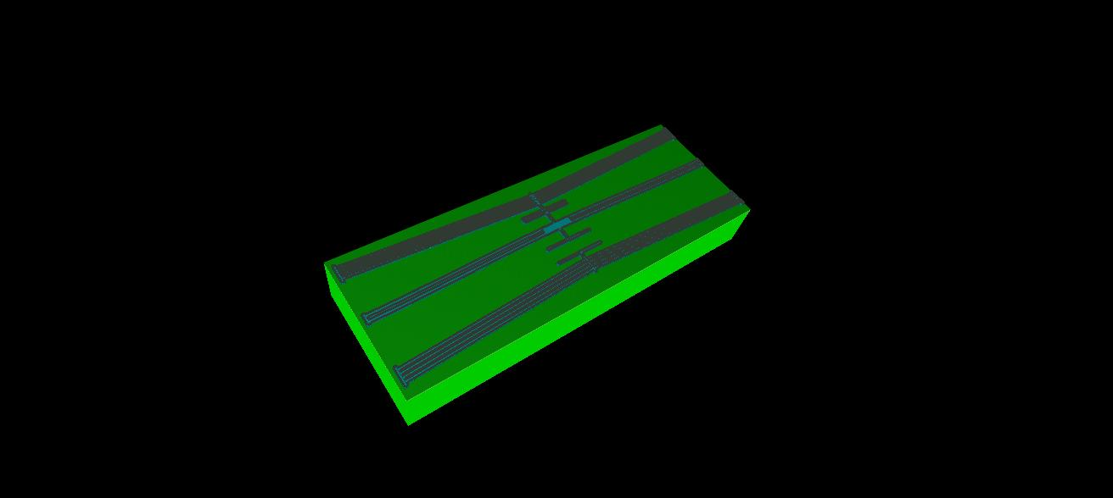

Step 9: Etching of Silicon (The device layer Silicon has been exposed to the mask structure and Silicon in the remaining area has to be etched)

Database --> Etch --> Si --> DRIE --> SF6_C4F8 --> Partial Etching

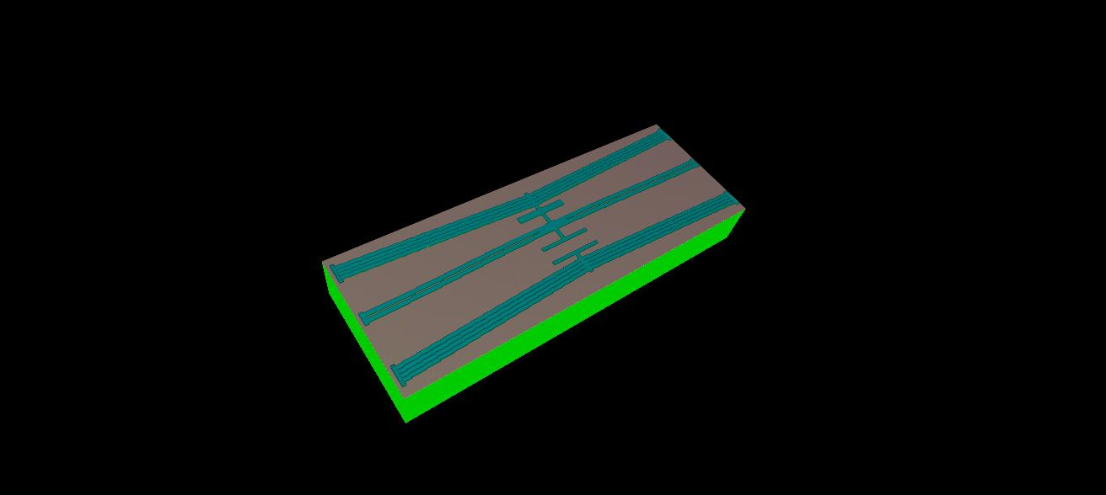

Step 10: Etching of Photoresist

Database --> Etch --> PR-AZ5214 --> Wet --> Lift-off --> Partial etching

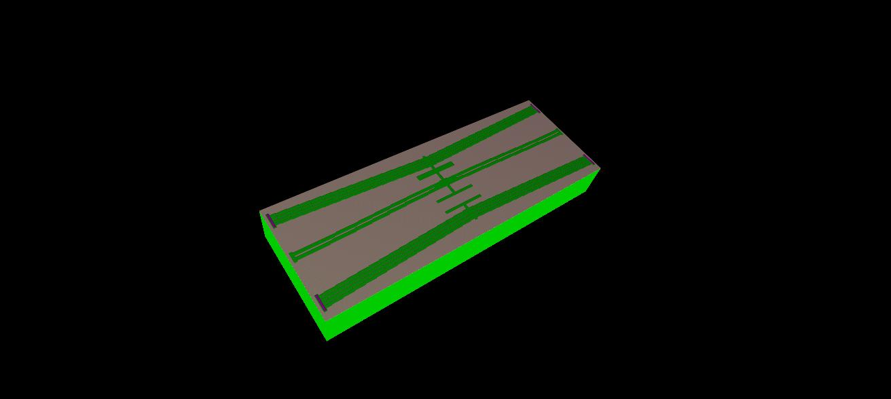

Step 11: Deposition of Photoresist (For the purpose of the third mask (trench) to be uploaded)

Database --> Deposition --> PR-AZ5214 --> Spin --> 001 (Non-Conformal Deposition)

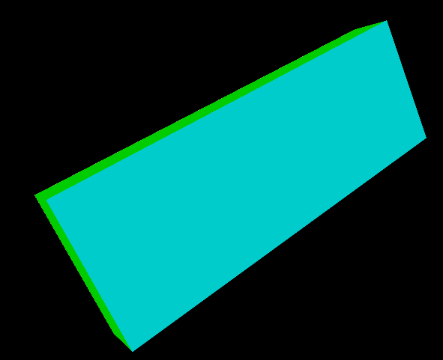

**Note: The trench mask has to be uploaded at the bottom side as the process of etching the substrate silicon and the oxide needs to be done at the bottom side**

Step 12: Exposure of UV rays (The mask structure of the device which has been drawn in layer 2 in the blueprint module has to be uploaded in the fab file)

Database --> Exposure --> UV --> Contact --> Suss

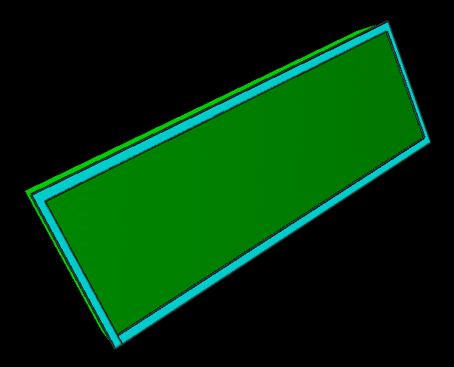

Step 13: Etching of Silicon (The substrate Silicon has been exposed to the trech mask structure and Silicon in the remaining area has to be etched)

Database --> Etch --> Si --> DRIE --> SF6_C4F8 --> Partial Etching

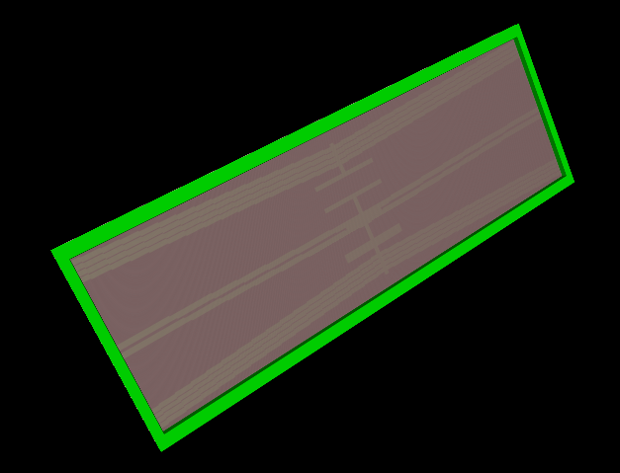

Step 14: Etching of Photoresist

Database --> Etch --> PR-AZ5214 --> Wet --> Lift-off --> Partial etching

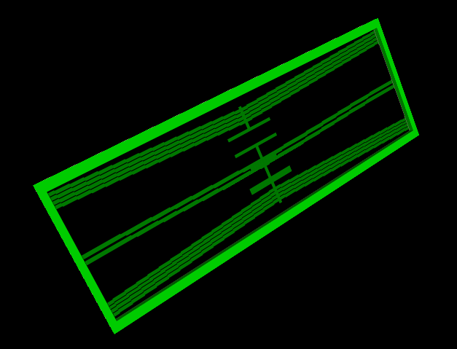

Step 15: Etching of SiO2

Database --> Etch --> SiO2 --> RIE --> CHF3_CF4 --> Partial etching

